**Installing DAL as a Windows Service on Windows7**

1. Copy the enclosed directory to a directory that doesn’t change. A typical name might be C:\ADTS_DAL
2. In the above directory, there are 2 bat files: one for installing the service, and one for un-installing the service.
3. Open the InstallService.bat file FOR EDIT.
4. Modify the line Set SERVICE_HOME=<DirectoryWhereExecutableReside> so that the highlighted part contains the location on the disk where you placed the files in step 1.
5. Open Windows Explorer, go to the directory \Windows\SysWoW64, locate the file Cmd.exe, right-click on it, and select “Run as Administrator”.
6. In the command window that was opened, navigate to the directory where you placed the files in step 1.
7. Execute “InstallService.bat”.
8. Successful installation would look like the following. Mote the success message at the bottom:

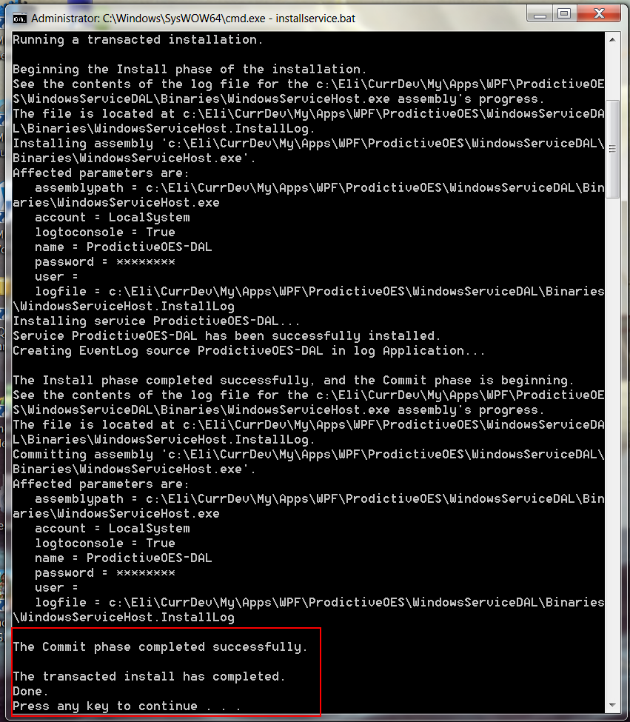

To verify, you can open the Control Panel, go to Administrative Tools, go to Services, and look for the following:

